Gold River Cat Society
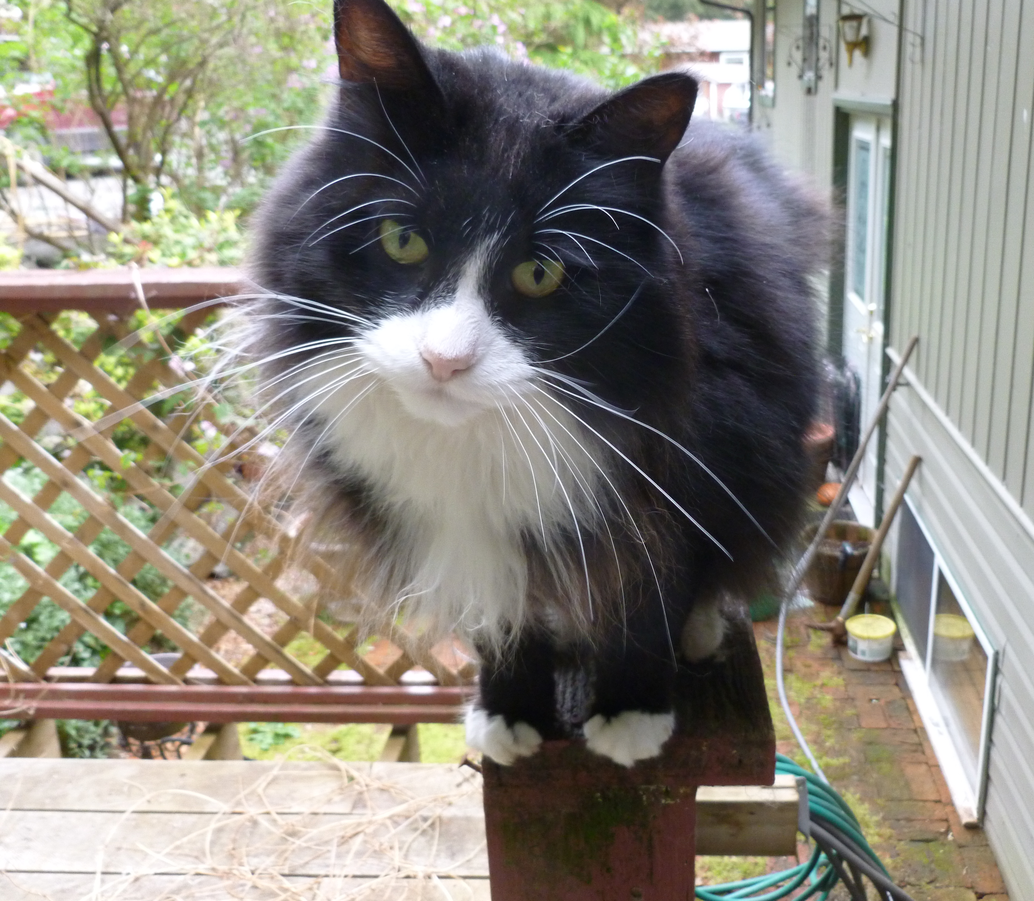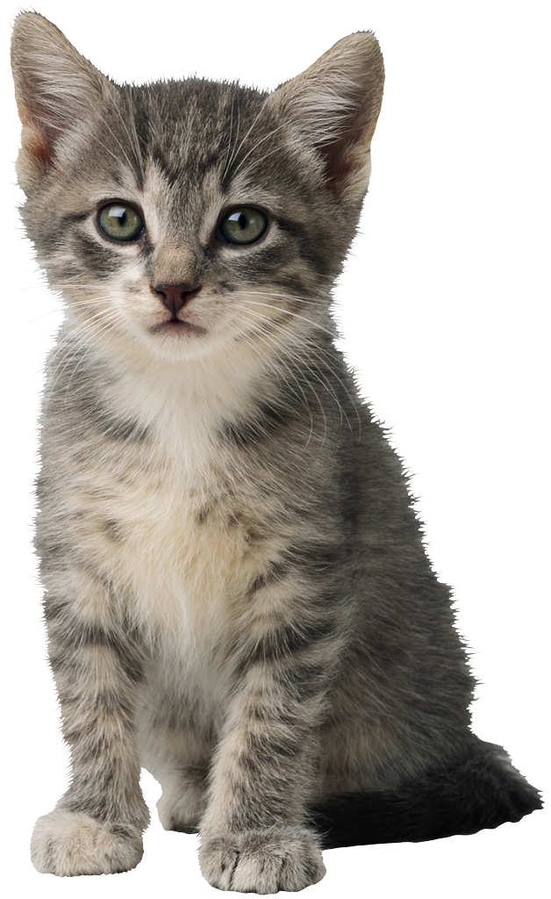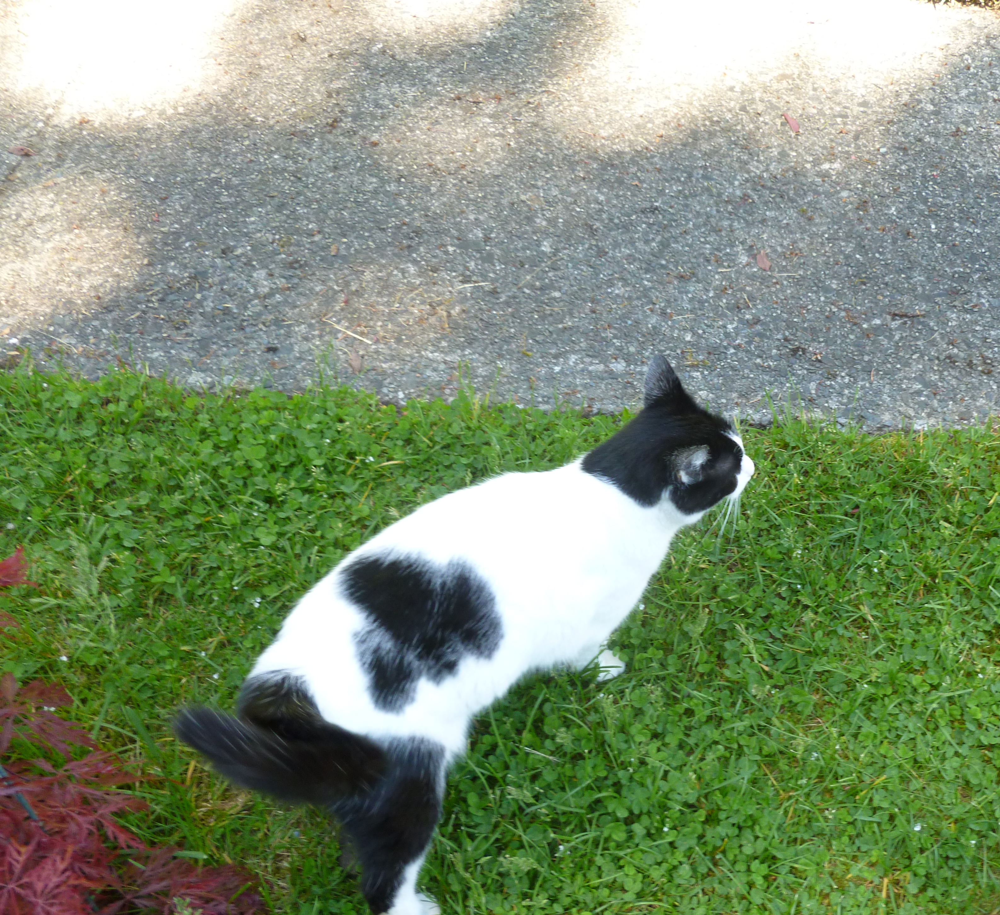
Worth their weight in Gold
P.O. Box 117
Gold River, B.C. V0P 1G0
250-283-7606
Registered Society # S-0062211
Registered Charity #82838 0378 RR0001

AGM Minutes Tuesday, February 18, 2025

A) Call to Order: 7:05 pm
B) Attendance: All but J Witton,
C) Adoption of the Agenda: MH/DD CARRIED
D) Adoption of Minutes from last meeting: DD/MH PASSED
E) Old Business: 1. Appreciation for volunteers (to be done asap)

F) New Business:
1. Change in directorship- Janet Witton wants to step back; Laura Brunning has agreed to replace her

2. Positions: First Director/ President- Joanne Folkins
Secretary- Joanne Folkins
Treasurer- Sharon Alstrup
Fundraising- Mandy Howie

3. Financial Report: See attached

4.. BC Society status $40/year.

5.. Charity Status: Effective Date was February 24, 2015; Fiscal Period ends January 31
every year

6. Cats Helped: 2024- Kittens: 19 at approx.. 10 weeks old; 3 less than a year old but old
enough to be spayed

Cats: 4

Fosterers- The Flams have agreed to foster again; Mandy Howie has been our main life saver this year; Laura Brunning has helped a lot as well

7. Other: (a) Zoe- Long story; chosen my neighbor to be her guardian

8. Fundraising ideas- Best this year were the Kitten Cuddles with Bake Sales and the returnables account. Hobby Hill Farms was OK. The others weren’t. Want to do Burgers and Beer this summer; First Responders want to do a car wash for us.

G) Adjournment at 7:40 pm

